## **Installing Self-signed certificate in PCF environment**

While setting up the PCF ER, we need to provide the certificate for secured access. Also it is a requirement for many services to be installed. One of such service is Spring Cloud Service, which has a basic requirement to find below signed URLs.

**Security Requirements:**

You will need to update your Elastic Runtime SSL certificate as described in the Pivotal Cloud Foundry® documentation. Generate one single certificate that includes all of the domains listed below, replacing SYSTEM_DOMAIN.TLD with your system domain and APPLICATION_DOMAIN.TLD with your application domain:

*.SYSTEM_DOMAIN.TLD

*.APPLICATION_DOMAIN.TLD

*.login.SYSTEM_DOMAIN.TLD

*.uaa.SYSTEM_DOMAIN.TLD

So in our case we need self-signed certs for following domains:

*.pcf.inbcu.com

*.apps.pcf.inbcu.com

*.login.pcf.inbcu.com

*.uaa.pcf.inbcu.com

Steps:

1. Login to ops.pcf.inbcu.com with admin credentials.
2. Click on Elastic Runtime tab.
3. Click on “*Generate Self-signed RSA certificate*”.

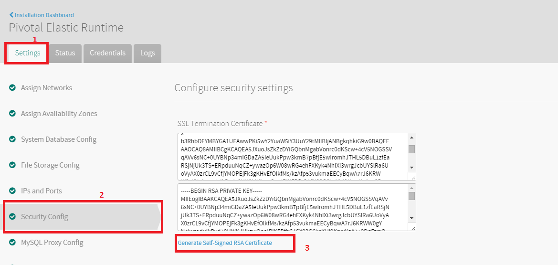

1. Put these values ***“*.pcf.inbcu.com,*.apps.pcf.inbcu.com,*.login.pcf.inbcu.com,*.uaa.pcf.inbcu.com”*** in the provided text-box and click ***Generate***.
2. The certificate will be added in SSL Terminate Certificate boxes.
3. Enable “Ignore SSL certificate verification” by ticking the box.
4. The next step is tricky, because without it our application will throw error. The application that is dependent on SCS, will throw error while trying to register. Below is the error message :

*"Caused by: sun.security.validator.ValidatorException: PKIX path building failed: sun.security.provider.certpath.SunCertPathBuilderException: unable to find valid certification path to requested target"*

1. To avoid this, we need to add the self-signed certificate to JVM Truststore.
2. Here, we had added Self-Signed SSL Certificate to JVM Truststore which we did by the following command:
3. App Name: datamaker-poc16
4. Env Name: <https://api.pcf.inbcu.com/>
5. Commands to execute after we go to the target Org "SalesAnalyticsProducts" and Space "datamaker-upgrade"
6. Commands:

|  |
| --- |
| cf set-env datamaker-poc16 CF_TARGET <https://api.pcf.inbcu.com/>  cf restage datamaker-poc16 |

1. The error logs will vanish.

We are good to use Spring Cloud Service and bind the services like Service Registry and Circuit Breaker in our application.